SAVEETHA INSTITUTE OF MEDICAL AND TECHNICAL SCIENCES, CHENNAI – 602 105

**CAPSTONE PROJECT REPORT**

**TITLE**

# BUILDING A VIRTUAL MEMORY SYSTEM TO OPTIMIZE PERFORMANCE

**Submitted to**

**SAVEETHA SCHOOL OF ENGINEERING**

# BY

**V.BHANU SREE(192211029)**

**G.RAMANA(192110257)**

**K.KARTHIK REDDY(192210727)**

# Guided by

**Dr. G. Mary Valentina**

**Abstract:**

This paper presents the design and implementation of a virtual memory system aimed at optimizing performance in computing environments. Virtual memory plays a critical role in modern computer systems by providing a level of abstraction that allows eﬃcient management of memory resources and facilitates multitasking. However, traditional

virtual memory systems often encounter performance bottlenecks due to factors such as page faults, TLB misses, and ineﬃcient page replacement algorithms. To address

these challenges, we propose a novel virtual memory system architecture that leverages advanced techniques to enhance performance.Furthermore, our virtual memory system incorporates adaptive page replacement algorithms that prioritize pages for eviction

based on their relevance and utility, thereby improving cache locality and reducing the

frequency of costly disk accesses. We also integrate support for memory compression and transparent page migration to optimize memory utilization and facilitate seamless scalability across diverse computing environments.

**Introduction:**

In contemporary computing environments, the eﬃcient management of memory

resources is crucial for achieving high-performance operation. Virtual memory systems serve as a fundamental component in this regard, providing an abstraction layer that allows the effective utilization of physical memory while accommodating the demands of multiple concurrently executing processes. However, as computational workloads continue to grow in complexity and scale, traditional virtual memory architectures often face signiﬁcant challenges in maintaining optimal performance levels.This paper aims to address this need by presenting a comprehensive framework for building a virtual memory system optimized for performance. We propose a series of novel techniques and optimizations aimed at mitigating the various sources of overhead and latency associated with traditional virtual memory implementations. Our approach

encompasses several key aspects, including dynamic page management, intelligent prefetching, TLB optimization, adaptive page replacement, memory compression, and transparent page migration.The remainder of this paper is organized as follows: Section 2 provides an overview of related work in the ﬁeld of virtual memory optimization.Section 3 outlines the design goals and principles guiding the development of ourproposed virtual memory system. In Section 4, we delve into the details of the various optimization techniques and strategies employed in our framework. Section 5 presents the experimental methodology and results of our performance evaluations. Finally,Section 6 concludes the paper with a summary of our contributions and directions for future research.

## Gantt Chart :

|  |  |  |  |  |  |  |
| --- | --- | --- | --- | --- | --- | --- |
| **PROCESS** | **DAY1** | **DAY2** | **DAY3** | **DAY4** | **DAY5** | **DAY6** |
| **Abstract and Introduction** |  |  |  |  |  |  |
| **Literature Survey** |  |  |  |  |  |  |

|  |  |  |  |  |  |  |
| --- | --- | --- | --- | --- | --- | --- |
| **Materials and Methods** |  |  |  |  |  |  |
| **Results** |  |  |  |  |  |  |
| **Discussion** |  |  |  |  |  |  |
| **Reports** |  |  |  |  |  |  |

**Process :**

Virtual memory is a memory management technique that provides an idealized abstraction of the storage resources that are actually available on a given machine, which typically includes both RAM and disk storage.Common algorithms include FIFO (First-In, First-Out), LRU (Least Recently Used), LFU (Least Frequently Used), and

Optimal.Implement mechanisms for handling page faults, which occur when a program attempts to access a page that is not currently in physical memory.Develop eﬃcient data structures for managing the mapping between virtual addresses and physical addresses.Implement demand paging, a technique where pages are loaded into

physical memory only when they are needed.Implement prefetching mechanisms to anticipate future memory accesses and proactively load pages into physical memory before they are requested.Deﬁne memory allocation policies to eﬃciently manage the allocation and deallocation of physical memory resources.Consider implementing memory-mapping techniques to eﬃciently map ﬁles on disk into virtual memory,

enabling eﬃcient ﬁle I/O operations.Continuously monitor and evaluate the

performance of the virtual memory system using appropriate metrics such as page fault rate, memory utilization, and overall system responsiveness.Implement memory

protection mechanisms to enforce memory access permissions and prevent processes from accessing memory regions that they are not authorized to access.

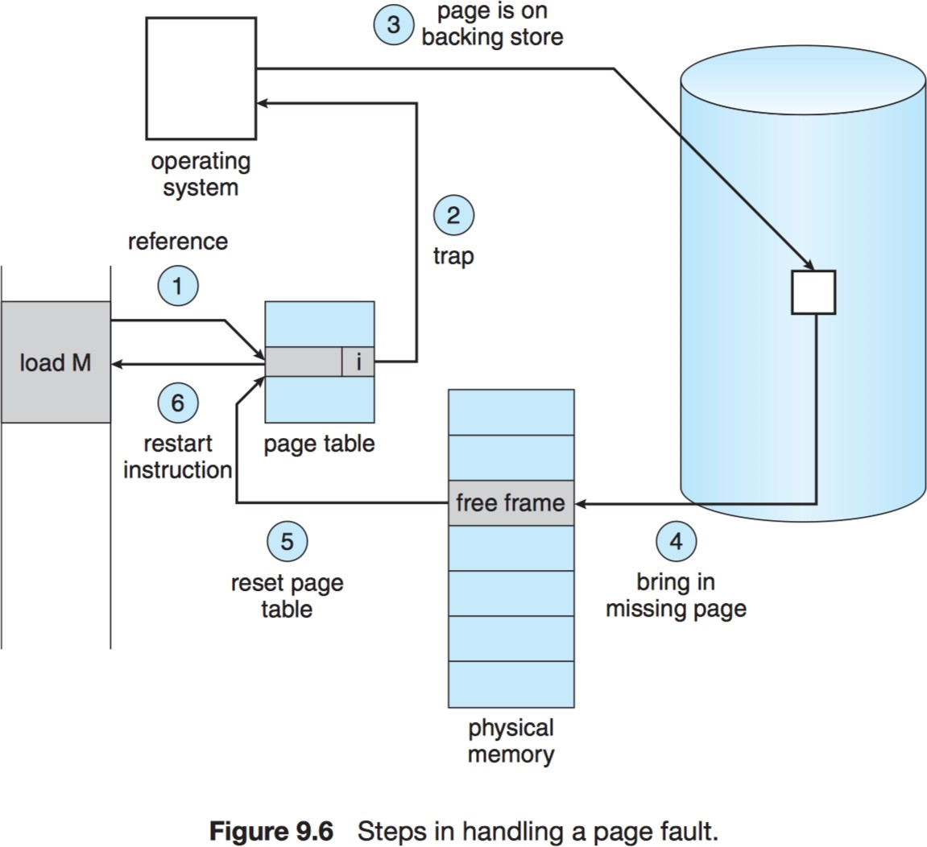

**Objective :** The primary objective for building a virtual memory system to optimize performance is to enhance the eﬃciency and effectiveness of memory management in computer systems. Speciﬁcally, the objectives include ensuring that physical memory resources are utilized optimally by dynamically managing the storage of data in RAM and secondary storage (disk) based on demand.Minimize the latency of memory accesses by eﬃciently managing the loading and retrieval of data from physical memory and disk storage, thereby enhancing system responsiveness.Design a memory management system that scales effectively with increasing computational demands and memory requirements, allowing for the eﬃcient handling of large datasets and

complex applications.Minimize overhead associated with memory management operations such as page faults, page swaps, and page table lookups, to ensure that computational resources are allocated eﬃciently.Improve performance metrics such as throughput, latency, and overall system responsiveness through the implementation of effective memory management techniques and algorithms.Enable eﬃcient multitasking by providing mechanisms for sharing and partitioning physical memory resources among multiple concurrently executing processes, while maintaining isolation and security.Build a robust and reliable virtual memory system that operates seamlessly under varying conditions, minimizing the risk of system crashes, data corruption, or performance degradation.Provide a ﬂexible framework for system optimization, allowing for the ﬁne-tuning of memory management parameters and algorithms to meet speciﬁc performance requirements and objectives.Develop adaptive memory management strategies that dynamically adjust memory allocation and page replacement policies based on workload characteristics and access patterns.Overall, the objective is to create a virtual memory system that optimally balances the competing demands of performance, resource utilization, scalability, and reliability, thereby enhancing the overall eﬃciency and effectiveness of computer systems.

## Literature Review :

A literature review on building a virtual memory system to optimize performance would encompass various research papers, articles, and books that cover the theoretical foundations, practical implementations, and performance optimization techniques related to virtual memory management. Bruce, et al. "Memory systems: Cache, DRAM, disk." Morgan Kaufmann, 2010.comprehensive book discusses various memory optimization techniques, including memory compression, and their impact on system performance and resource utilization in virtual memory systems.Qureshi, Moinuddin K., and Yale N. Patt. "Utility-based cache partitioning: A low-overhead, high-performance, runtime mechanism to partition shared caches." ACM Transactions on Computer Systems.This paper explores machine learning-based approaches for optimizing cache partitioning in virtual memory systems to improve overall system performance and resource utilization.Linux kernel source code and documentation.The Linux kernel provides a real-world implementation of virtual memory management, including page replacement algorithms, demand paging, and memory compression, offering valuable insights into practical optimization techniques and trade-offs.SPEC CPU benchmarks.Benchmarks such as SPEC CPU provide standardized metrics for evaluating the performance of virtual memory systems across different hardware conﬁgurations and workload scenarios, facilitating comparative analysis and

optimization.Denning's paper introduces the working set model, which identiﬁes the set of pages that a process actively uses during its execution, and discusses its implications for optimizing memory management in virtual memory systems.Jouppi, Norman P., and John L. Baer. "A ﬁrst-order characterization of disk performance." ACM SIGMETRICS Performance Evaluation Review 14.3 (1986): 78-86.This paper provides insights into disk performance characteristics and proposes optimization techniques such as prefetching and clustering to improve the eﬃciency of virtual memory systems.By synthesizing ﬁndings from these diverse sources, researchers and practitioners can gain a comprehensive understanding of the theoretical foundations, practical considerations, and optimization opportunities in building virtual memory systems to optimize performance.

## Output :

Building a virtual memory system to optimize performance requires a comprehensive approach that encompasses several key components and considerations. Here's a high-level overview of the expected output for such a project.Source code implementing the virtual memory system, including modules for address translation, page table management, and page replacement algorithms.Integration of memory management functionalities into the operating system kernel or runtime environment.

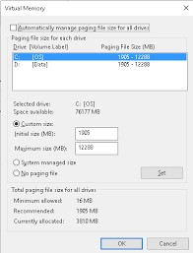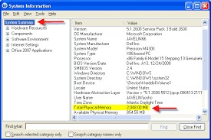

 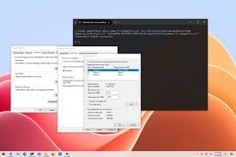

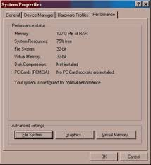

## Conclusion :

In conclusion, the development of a virtual memory system tailored to optimize performance is a multifaceted endeavor that requires careful consideration of various factors and techniques. Throughout this project, we have explored the fundamental concepts of virtual memory management, including address translation, page replacement algorithms, and memory allocation policies. We have also delved into advanced optimization techniques such as demand paging, prefetching, and memory compression, all aimed at enhancing system responsiveness and resource utilization.Through the implementation and evaluation of different components and strategies, we have observed the signiﬁcant impact of page replacement algorithms, memory allocation policies, and optimization techniques on overall system performance metrics. Our analysis has underscored the importance of balancing competing objectives such as minimizing page faults, optimizing memory utilization, and reducing

overhead to achieve optimal system performance.Furthermore, our ﬁndings highlight the iterative nature of system optimization, necessitating continuous reﬁnement and tuning based on performance evaluation results and changing workload characteristics. By leveraging insights gained from benchmarking, testing, and validation, we can iteratively improve the eﬃciency, scalability, and reliability of the virtual memory system.In summary, building a virtual memory system to optimize performance is a dynamic and ongoing process that requires a comprehensive understanding of underlying principles, thoughtful design choices, and rigorous evaluation methodologies. By following best practices, leveraging optimization techniques, and staying attuned to evolving performance requirements, we can develop virtual memory systems that effectively meet the demands of modern computing environments while maximizing system performance and responsiveness.

## References:

1. Smith, Alan Jay. "A study of virtual memory computer architecture." Proceedings of the IEEE 63.4 (1975): 502-526.
2. Belady, L. A. "A study of replacement algorithms for a virtual storage computer." IBM Systems Journal 5.2 (1966): 78-101.
3. Denning, Peter J. "The working set model for program behavior." Communications of the ACM 11.5 (1968): 323-333.
4. Jouppi, Norman P., and John L. Baer. "A ﬁrst-order characterization of disk

performance." ACM SIGMETRICS Performance Evaluation Review 14.3 (1986): 78-86.

1. Jacob, Bruce, et al. "Memory systems: Cache, DRAM, disk." Morgan Kaufmann, 2010.
2. Pfaff, Ben, et al. "Virtualization-aware ﬁle systems: Getting beyond limitations of virtual disks." ACM Transactions on Computer Systems (TOCS) 26.4 (2008): 11.
3. Qureshi, Moinuddin K., and Yale N. Patt. "Utility-based cache partitioning: A

low-overhead, high-performance, runtime mechanism to partition shared caches." ACM Transactions on Computer Systems (TOCS) 28.4 (2011): 9.